**Chapter – 1: Introduction**

* Furniture is the soul of a house; it gives a sense of fulfilling of needs. Types of furniture are of many designs and categories. It can be as small as a mouse to as gigantic as an elephant.
  + The aim of this system is to becomes self-reliant and attain financial
  + Independence by engaging in furniture making.
  + It was realized that the number of temporary customers are increasing due to increasing demand of furniture.
  + I came up with a Akshar furniture management system that will end all this.
  + Problems and bring the business to its standards.

|  |  |
| --- | --- |
| **1.1 Background** | |
| **Project Description** | It is a web application. This website for is created to help increase its sales as well as to acquire more customers in the furniture market. |
| **Project Duration** | 2 to 3 Month. |
| **Platform** | Windows 10 |
| **Technologies Used** | Microsoft .NET Framework 4.5 C#.NET |
| **Tools Used** | Microsoft Visual Studio 2008 MS Access 2007  MS Word 2007. |

**1.2 Objective**

* AKSHAR FURNITURE MANAGEMENT SYSTEM is a web application designed primarily for use in the furniture item delivery service and it also provide the information about our furniture store.
* This system will allow furniture store to increase scope of business by reducing the labor cost involved.
* The system also allows to quickly and easily manage an online items which customers can browse and use to place orders with just few clicks.
* The main point of developing this system is to help furniture store Administrator manage the furniture shop business and help customer for online ordering.
* Eliminate paper work and increase level of accuracy.
* Increase speed of service, sales volume and customer satisfaction.

**1.3 Purpose**

This online application enables the end users to register online, select the furniture from the furniture menu. An online orders.

By just selecting the furniture that the user want to have.

The user will be given a username and a password to login. Admin can view Customer details and product detail.

**1.4 Scope of System**

# System Profile:

This furniture center is committed to being the best in all areas of its business.

Online ordering system will be a website whose main language of programming will be ASP.NET. Its main aim is to simplify and improve the efficiency of the ordering process for both customer and shop, minimize manual data entry and ensure data accuracy and security during both order placement process. Customers will also be able to view product menus.

# MODULES:

**There is mainly two modules**

**Modules**

**User**

**Admin**

**MODULES FRONT-PAGE:-**

**Home:**

User can see furniture shop Details. Gallery, contact etc..

**Gallery:**

**About us:**

**Contact**

**Sign Up:**

**Login:**

User can see all furniture like sofa, Bed, Tables etc.

User can see details about our Furniture website.

User can see contact details our furniture Shop. And review.

User Registration.

**MODULES AFTER LOGIN BY USER:-**

**View Product:**

User can see Product Details.

**Order:**

User can see their all orders details. And new order.

**Feedback:**

User can provide feedback.

**Help:**

Help menu.

**Change Password:**

User can change his her password.

**Logout:**

User can logout from the website.

# MODULES AFTER LOGIN BY ADMIN:-

**Add Product**

**View Product:**

**Order Detail:**

**Suggestions**:

Admin can add new furniture product.

Admin can see stock details.

Admin can see all the orders details which is given by The customer/user.

Admin can see Suggestion which is given by the user.

**Customer Data:**

Admin can see all the details of user/customer which is Register or login in website.

**Change Password:**

Admin can change password.

**Logout:**

Admin can logout from website.

# Scope:

Scope and Limitation for Online Furniture shop System is a still uses a manual procedure in keeping records of their clients and past, current and upcoming. In making an order the client must fill-up some forms such as waiver/ gate pass and the ordering.

This type of process best applies to walk-in customers only since they have the privilege of looking...

**Chapter – 2 : Requirement and Analysis**

**2.1 Problem definition**

* The existing system is manual system.

* Needs to be converted into automated system.
* As it has a risk of mismanagement of data, less Security, no proper coordination between die rent Applications and Users, fewer users - friendly, accuracy not guaranteed and not in reach of distant users.

**2.2 Requirement Specification**

* A system’s requirement analysis is an important component of the

system development process.

* This perhaps the most important and essential ingredient of the system analysis phase and its proper completion ensures the success of the entire system.
* It establishes what the new system must do, it involves identifying who needs what information, where, when and how.
* It also identifies the data, process and interface requirements for the users of the new system.
* Errors and omissions in requirement analysis result in user dissatisfaction with the final system and it will force to be highly cost and incur heavily loss.
* The ultimate goal of the requirement analysis is the creation of the requirement specification for the new system.

# Functional Requirement

* The only requirement is to automate the whole system as a good source of providing the reliable information to that the user so that he can get the maximum benefit of the services provided by the campus/organization.

# Non-functional Requirement

The supplementary specification applies to furniture. This specification defines the non-functional requirement of the system such as:

# Functionality

Since it web application, one or more user may use it at a time using the web over the internet.

## Usability

Web Browser interface

Any operating system running the latest version of the browser

## Reliability *:*

The system is available during online time mode using the internet.

## Performance*:*

The performance depends on hardware specification of the server used.

**2.3 Hardware Requirements**

* + Processor Dual core or above
  + HDD 500 GB
  + RAM 1 GB

**2.4 Software Requirements**

## Frontend Technology

* + 1. ASP.NET
    2. Browser

## Backend tools

* + - 1. MS Access 2007

**2.5 Planning Scheduling**

## Software Project Planning

* Goal is to establish a pragmatic strategy for controlling, tracking, and monitoring a complex technical project
* Must deal with:
* Project complexity: has a strong effect but is heavily influenced by past practitioner experience
* Project size: as size increases the interdependency of elements also grows. Watch out for scope creep (when customers change requirements mid-cycle)
* The degree of structural uncertainty: the degree to which requirements are solidified and the ease of functional decomposition.

The purpose of project planning is to ensure that the end result is completed on time, within budget, and exhibits quality!

# Project Planning

The main focus of the project was to create a single working “furniture shop” management system that acts as both a terminal for taking orders and a terminal for generating reports and making changes to items on the menu.

Project planning was done to define the scope of the project, assess risks, and estimate and schedule project activities and thereby lay the foundation for the execution, monitoring and control of the project.

## Study of the Problem

The furniture is critical to set up online order, customers to browse through the furniture categories**.** This is a small scale project for furniture shop.

**CUSTOMER**

**CUSTOMER ROLE:**

The customers can login/logout the System. He /She can view his/her furniture details.

# Scheduling

The project scheduling is a mechanism to communicate what tasks need to get done and which organizational resources will be allocated complete those tasks in what timeframe.

A project scheduling is a document collecting all the work needed to deliver the project on time.

**Spiral Model**

The spiral model combines the idea of iterative development with the systematic, controlled aspects of the waterfall model. This Spiral model is a combination of iterative development process model and sequential linear development model i.e. the waterfall model with a very high emphasis on risk analysis. It allows incremental releases of the product or incremental refinement through each iteration around the spiral.

# Spiral Model – Design

The spiral model has four phases. A software project repeatedly passes through these phases in iterations called Spirals.

# Identification

This phase starts with gathering the business requirements in the baseline spiral. In the subsequent spirals as the product matures, identification of system requirements, subsystem requirements and unit requirements are all done in this phase.

This phase also includes understanding the system requirements by continuous communication between the customer and the system analyst. At the end of the spiral, the product is deployed in the identified market.

# Design

The Design phase starts with the conceptual design in the baseline spiral and involves architectural design, logical design of modules, physical product design and the final design in the subsequent spirals.

# Construct or Build

The Construct phase refers to production of the actual software product at every spiral. In the baseline spiral, when the product is just thought of and the design is being developed a POC (Proof of Concept) is developed in this phase to get customer feedback.

Then in the subsequent spirals with higher clarity on requirements and design details a working model of the software called build is produced with a version number. These builds are sent to the customer for feedback.

# Evaluation and Risk Analysis

Risk Analysis includes identifying, estimating and monitoring the technical feasibility and management risks, such as schedule slippage and cost overrun. After testing the build, at the end of first iteration, the customer evaluates the software and provides feedback.

The following illustration is a representation of the Spiral Model, listing the activities in each phase.

**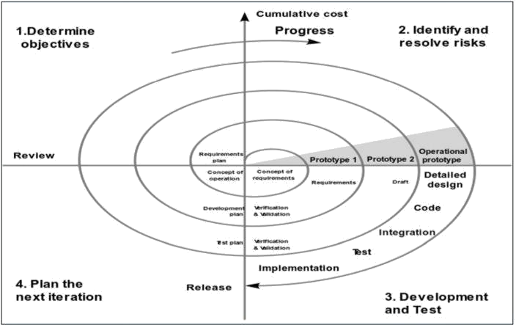[Spiral model]**

Based on the customer evaluation, the software development process enters the next iteration and subsequently follows the linear approach to implement the feedback suggested by the customer. The process of iterations along the spiral continues throughout the life of the software.

# Spiral Model Application

The Spiral Model is widely used in the software industry as it is in sync with the natural development process of any product, i.e. learning with maturity which involves minimum risk for the customer as well as the development firms.

# The following pointers explain the typical uses of a Spiral Model −

* When there is a budget constraint and risk evaluation is important.
* For medium to high-risk projects.
* Long-term project commitment because of potential changes to economic priorities as the requirements change with time.
* Customer is not sure of their requirements which is usually the case.
* Requirements are complex and need evaluation to get clarity.
* New product line which should be released in phases to get enough customer feedback.
* Significant changes are expected in the product during the development cycle.

# Spiral Model - Pros and Cons

The advantage of spiral lifecycle model is that it allows elements of the product to be added in, when they become available or known. This assures that there is no conflict with previous requirements and design.

This method is consistent with approaches that have multiple software builds and releases which allows making an orderly transition to a maintenance activity. Another positive aspect of this method is that the spiral model forces an early user involvement in the system development effort.

On the other side, it takes a very strict management to complete such products and there is a risk of running the spiral in an indefinite loop. So, the discipline of change and the extent of taking change requests is very important to develop and deploy the product successfully.

# The advantages of the Spiral SDLC Model are as follows –

Changing requirements can be accommodated. Allows extensive use of prototypes.

Requirements can be captured more

Development can be divided into smaller parts and the risky parts can be developed earlier which helps in better risk management.

**Chapter – 3 : System Design**

**DFD**

* Data flow diagram shows the way information flows through a process or system. It includes data inputs and outputs, data stores, and the various sub processes the data moves through. DFDs are built using standardized symbols and notation to describe various entities and their relationships.
* Data flow diagrams visually represent systems and processes that would be hard to describe in a chunk of text. You can use these diagrams to map out an existing system and make it better or to plan out a new system for implementation. Visualizing each element makes it easy to identify inefficiencies and produce the best possible system.

Symbol of DFD

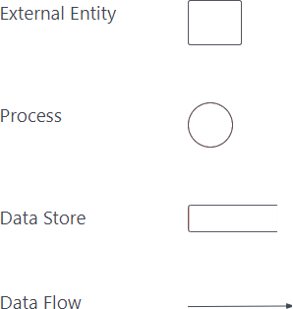

**[Figure 1: Symbol of DFD]**

# Data flow diagram levels

* **Level-0 DFD**
* Also known as context diagrams, are the most basic data flow diagrams. They provide a broad view that is easily digestible but offers little detail.

# Level-0 DFD

**Furniture Management**

**User**

**Admin**

**[System: 0 level DFD]**

**Level-1:-**

* Level 1 DFDs are still a general overview, but they go into more detail than a context diagram. In a level 1 data flow diagram, the single process node from the context diagram is broken down into sub processes. As these processes are added, the diagram will need additional data flows and data stores to link them together.

* **level-1 User:**

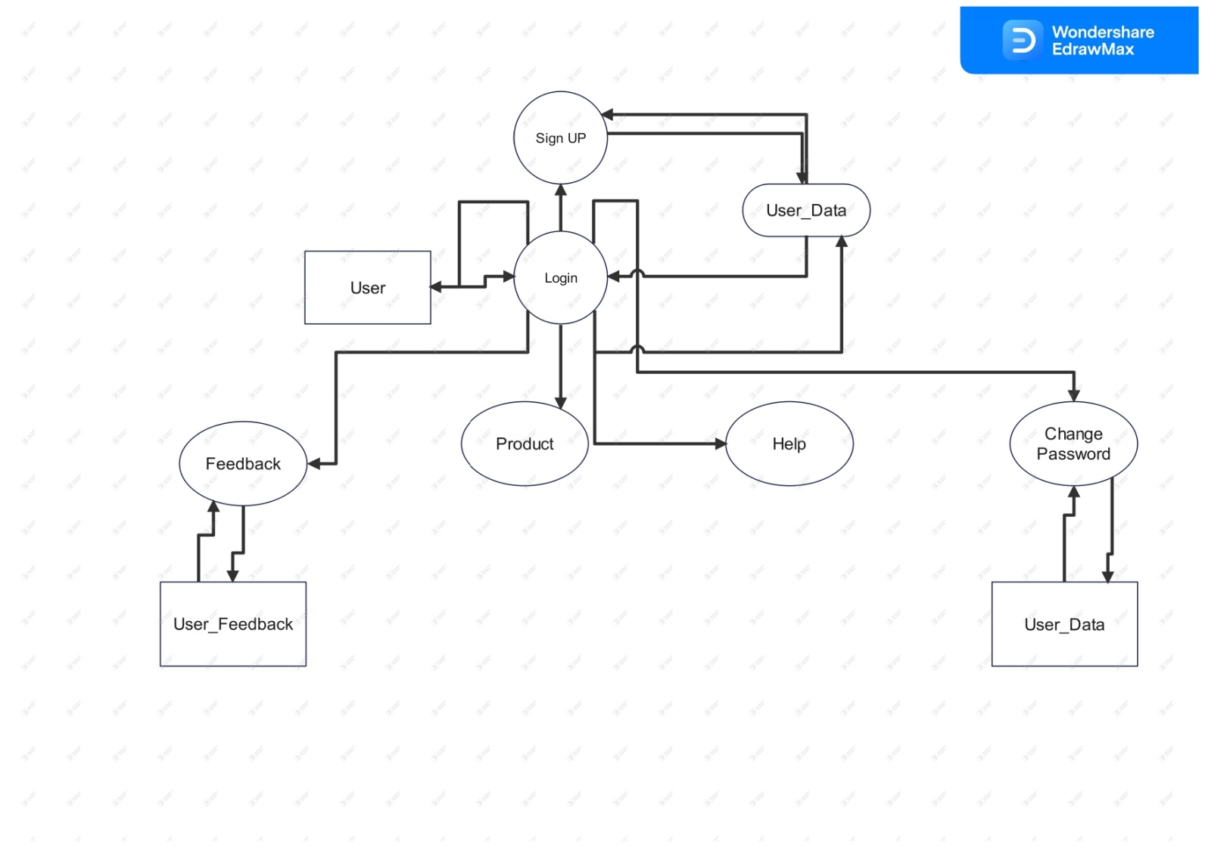

[User: 1st Level]

**level-1 Admin:**

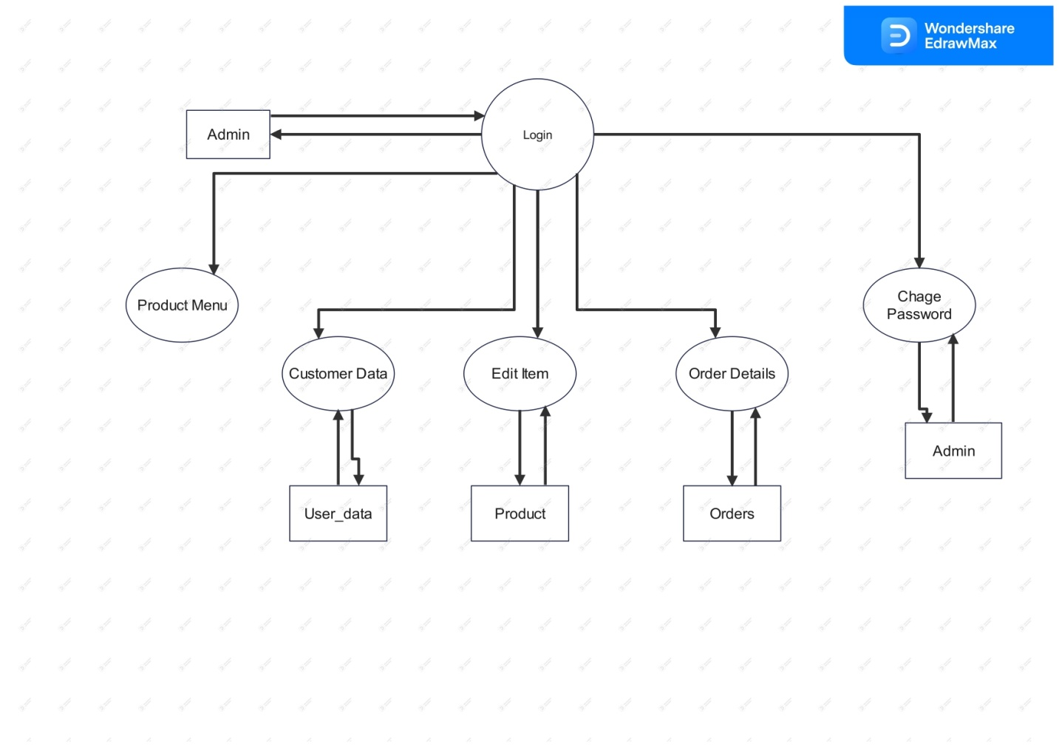

**[Admin 1st Level DFD]**

* **2nd Level DFD :User**

**Product**

**Product Detail**

**Order**

**Product**

**[User 2nd Level DFD]**

* **2nd Level DFD : Admin**

**Product**

**Manu**

View Product

Suggestions

Add Product

**contactmsg**

**Product**

**[Admin 2nd Level DFD]**

**E-R Diagram**

Entity Relationship Diagram, also known as ERD, ER Diagram or ER model, is a type of structural diagram for use in database design. An ERD contains different symbols and connectors that visualize two important information. The major entities within the system scope**,** and the inter-relationships among these entities**.**

# Table : user\_data

**username**

**o\_id**

**gender**

**cname**

**mobile**

**address**

**[Table user\_data: ER Diagram]**

**pass**

**user\_data**

**email**

* Table : User\_feedback

**mobile**

**User\_feedback**

**uemail**

**feedback**

**[Table user\_feedback: ER Diagram]**

**username**

**email**

**passadmin**

**mobile**

**Admin**

**[Table: Admin]**

**price**

**P\_name**

**product**

**p\_id**

**img**

**Has**

**[Table: product, orders: ER Diagram]**

**o\_id**

**date\_time**

**p\_id**

**quantity**

**amount**

**name**

**orders**

**mobile**

**firstnm**

**email**

**lastnm**

**mobile**

**Contactmsg**

**[ Table : contactmsg ]**

**Data dictionary**

|  |  |  |  |  |  |
| --- | --- | --- | --- | --- | --- |
| **Table No:** | | | **1** | | |
| **Table Name:** | | | **User\_data** | | |
| **Seq. no** | **Column**  **Name** | **Size** | **Column type** | **Column**  **description** | **Pk/fk** |
| 1 | o\_id | 10 | Auto Number | Customer  ID | **Primary key** |
| 2 | cname | 20 | Text | Customer Name |  |
| 3 | username | 30 | Text | Customer  username |  |
| 4. | gender | 10 | Text | Gender |  |
| 5. | mobile | 10 | Number(d  ouble) | Mobile |  |
| 6. | email | 30 | Text | Email Id |  |
| 7. | pass | 10 | Text | User  password |  |
| 8. | address | 30 | text | Address |  |

**[Table: user\_data]**

|  |  |  |  |  |  |
| --- | --- | --- | --- | --- | --- |
| **Table No:** | | | **2** | | |
| **Table Name:** | | | **User\_feedback** | | |
| **Seq. no** | **Column**  **Name** | **Size** | **Column type** | **Column**  **description** | **Pk/fk** |
| 1. | uemail | 30 | Text | User Email  ID |  |
| 2. | mobile | 10 | Number | Mobile  Number |  |
| 3. | feedback | 30 | Text | Customer Feedback |  |

**[ Table : user\_feedback]**

|  |  |  |  |  |  |
| --- | --- | --- | --- | --- | --- |
| **Table No:** | | | **3** | | |
| **Table Name:** | | | **Product** | | |
| **Seq. no** | **Column**  **Name** | **Size** | **Column type** | **Column**  **description** | **Pk/fk** |
| 1. | P\_id | 10 | Auto number | Product Id | **Primary key** |
| 2. | P\_name | 20 | Text | Product Name |  |
| 3. | price | 20 | Number | Product price |  |
| 4. | img | 50 | Text | Product Image |  |

**[Table: product]**

|  |  |  |  |  |  |
| --- | --- | --- | --- | --- | --- |
| **Table No:** | | | **4** | | |
| **Table Name:** | | | **Orders** | | |
| **Seq. no** | **Column Name** | **Size** | **Column type** | **Column description** | **Pk/fk** |
| 1. | o\_id | 10 | Number | Order id |  |
| 2. | P\_id | 10 | Number | Product id | fk |
| 3. | name | 20 | Text | Product  Name |  |
| 4. | amount | 10 | Number | Product Price |  |
| 5. | Quantity | 10 | Number | Product  quantity |  |
| 6 | date\_time | 10 | Date / Time | Order Date |  |

**[Table: orders]**

|  |  |  |  |  |  |
| --- | --- | --- | --- | --- | --- |
| **Table No:** | | | **5** | | |
| **Table Name:** | | | **Admin** | | |
| **Seq. no** | **Column**  **Name** | **Size** | **Column type** | **Column**  **description** | **Pk/fk** |
| 1. | username | 30 | Text | Admin  username |  |
| 2. | passadmin | 15 | Text | Admin password |  |
| 3. | mobile | 12 | Number(Double) | Admin mobile number |  |
| 4 | Email | 30 | Text | Admin email  id |  |

**[Table: Admin]**

|  |  |  |  |  |  |
| --- | --- | --- | --- | --- | --- |
| **Table No:** | | | **6** | | |
| **Table Name:** | | | **Contactmsg** | | |
| **Seq. no** | **Column**  **Name** | **Size** | **Column type** | **Column**  **description** | **Pk/fk** |
| 1. | firstnm | 15 | Text | First Name |  |
| 2. | lastnm | 15 | Text | Last Name |  |
| 3. | mobile | 12 | Number(Double) | Mobile Number |  |
| 4 | Email | 30 | Text | Email id |  |
| 5 | Msg | 30 | Text | Message |  |

**[Table: contact\_msg]**

**Input & output design**

* **Front Page View:**

**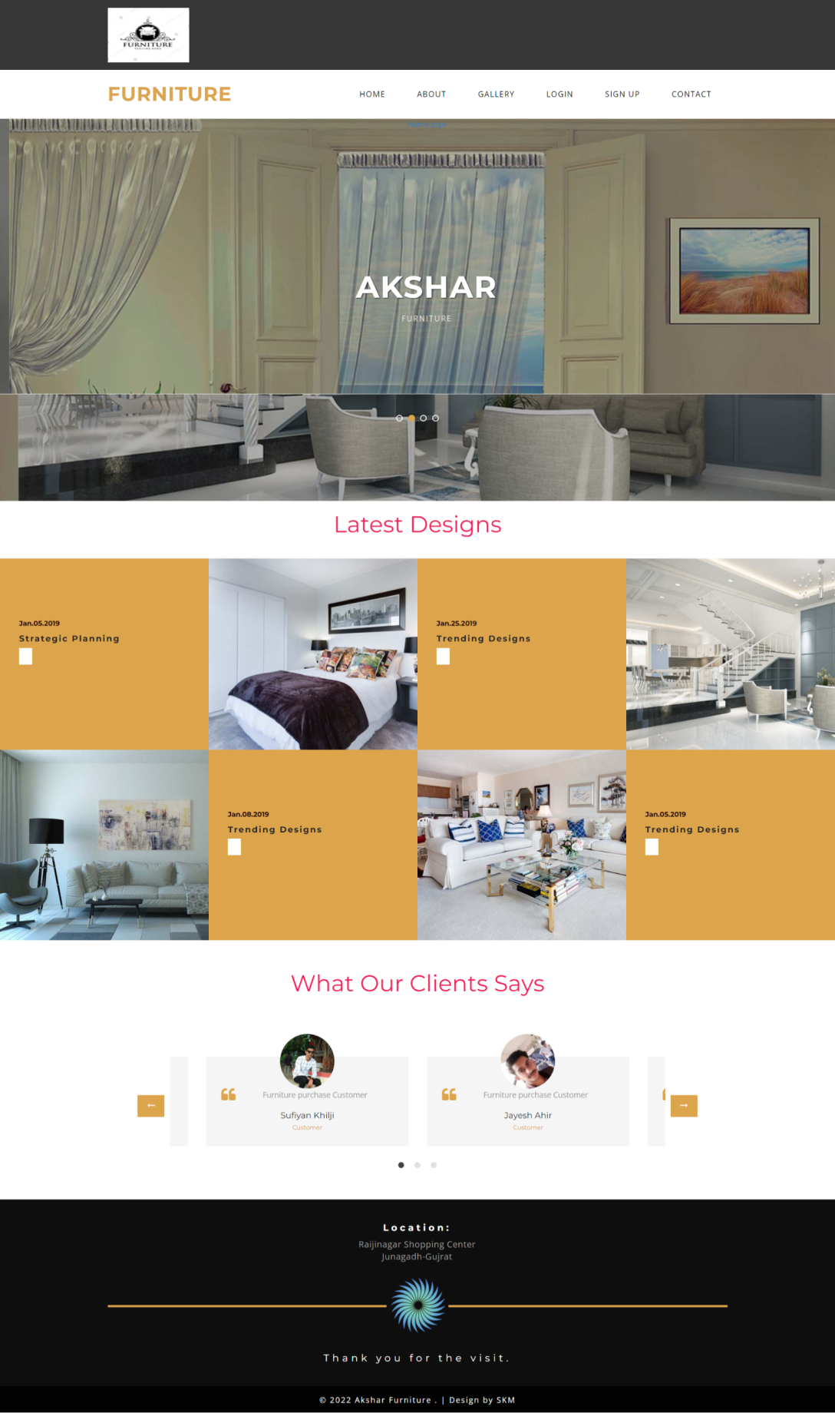**

**[Front Page: Home]**

# About:

**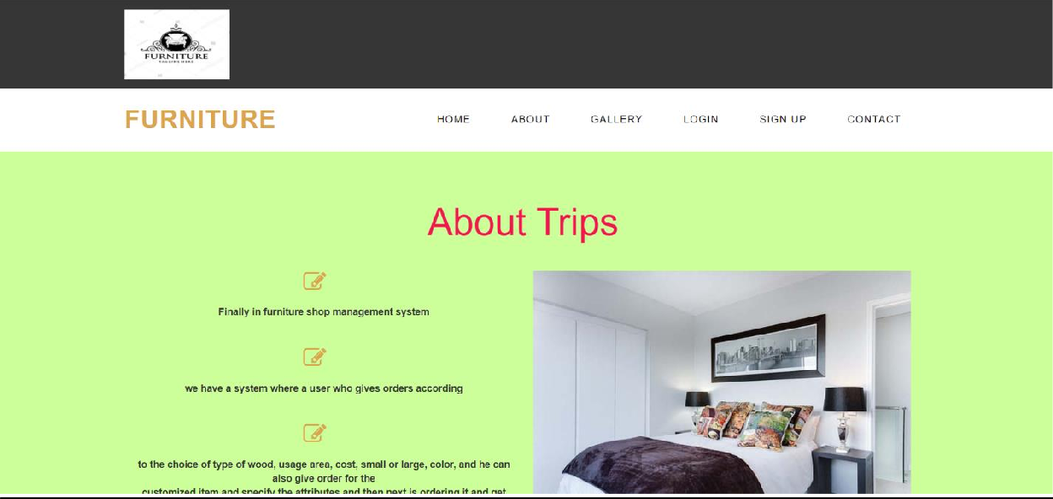 [About us]**

# Gallery:

**[Gallery]**

* **Sign In:**

# 

**[Login menu]**

# Sign Up:

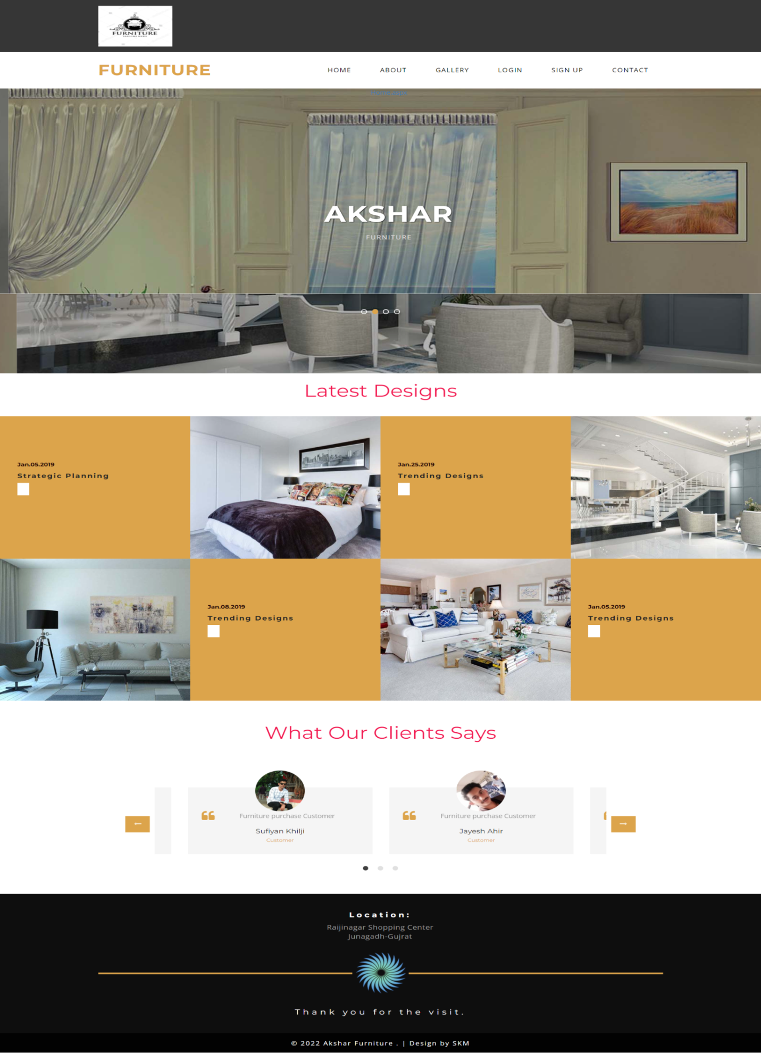  
**[User: Registration]**

# Contact:

# 

**[Contact]**

# User - Forgot Password:

# 

**[User – Forgot Password]**

**User Side**

* **User authority:**

**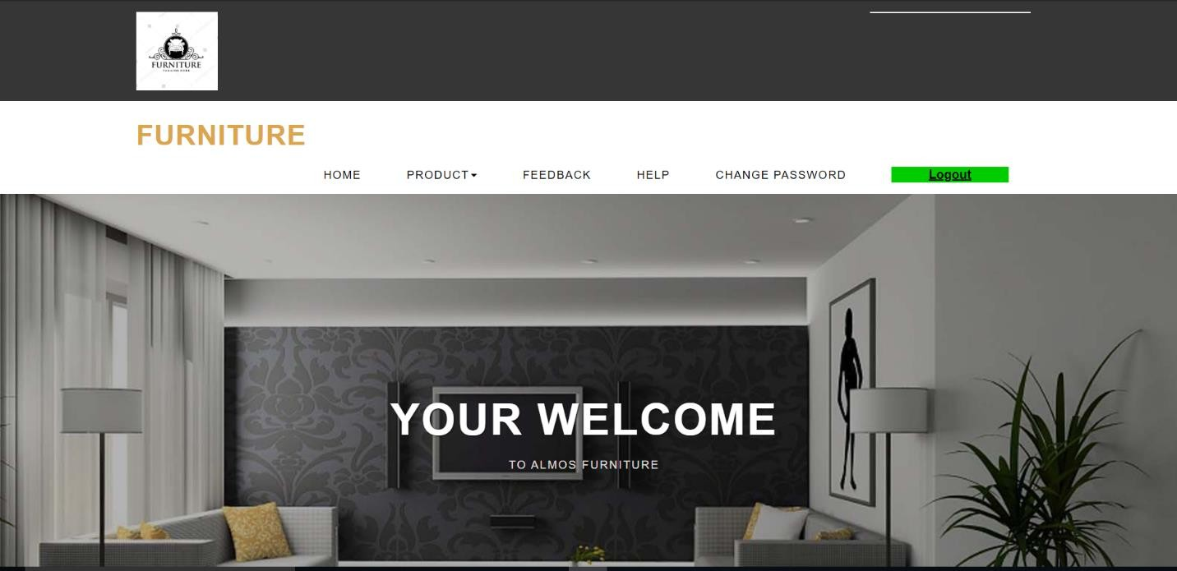**

# [User Authority]

* **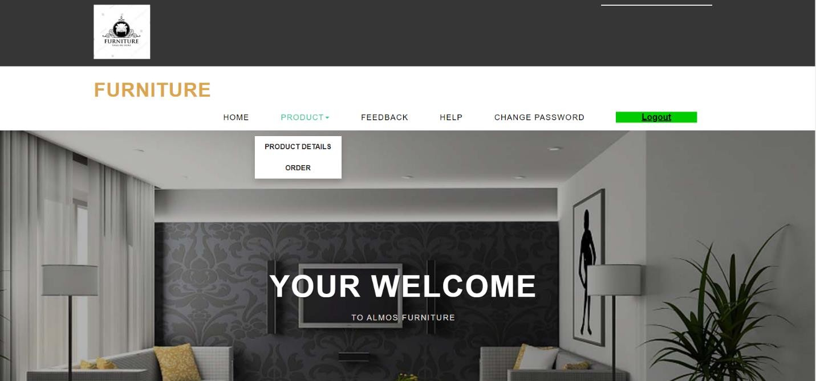Product:**

**[Product]**

* **View**

**[View Product]**

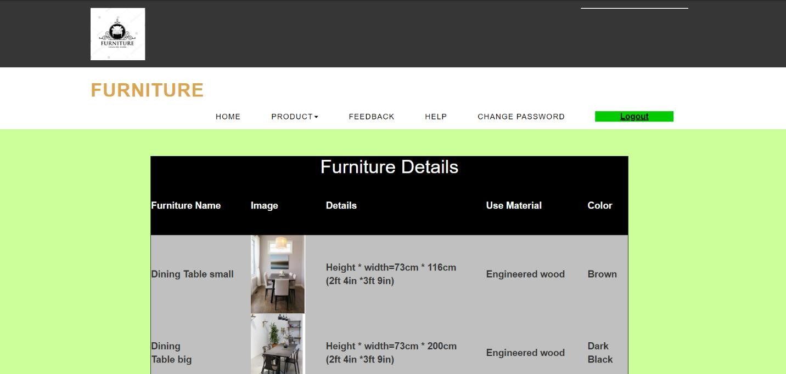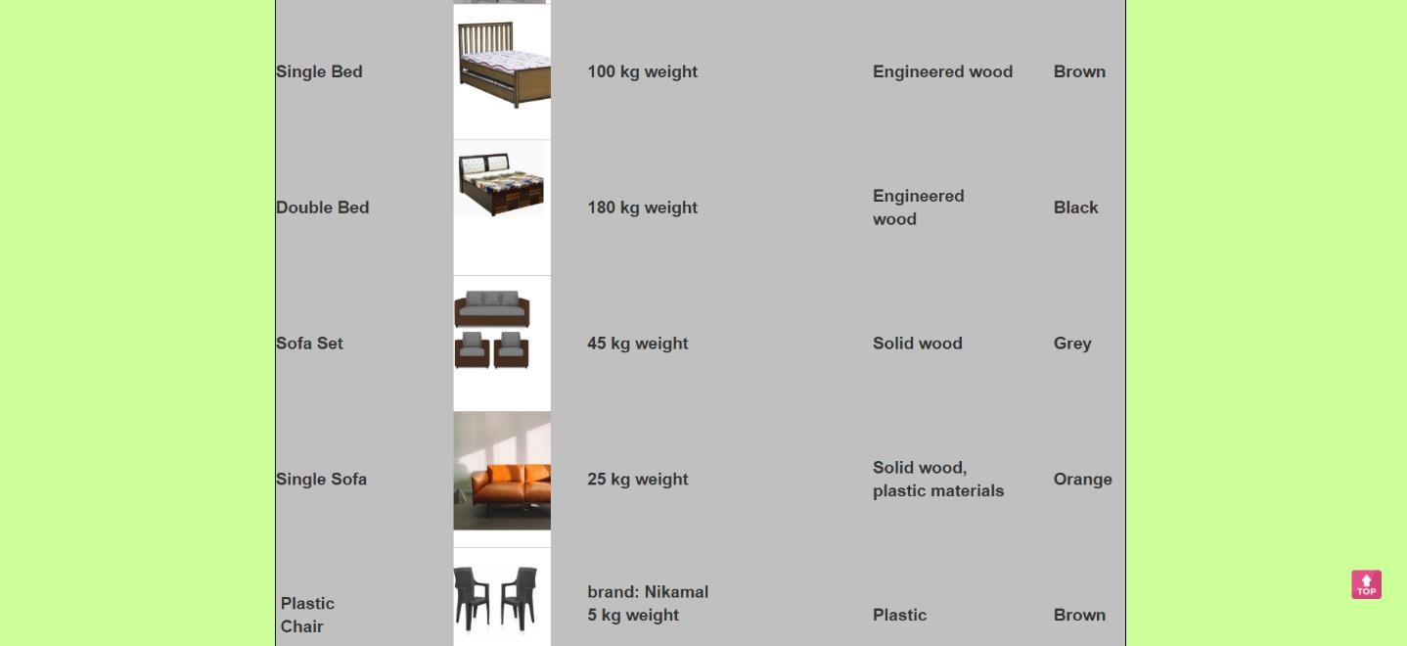

# Furniture(Order):

# 

**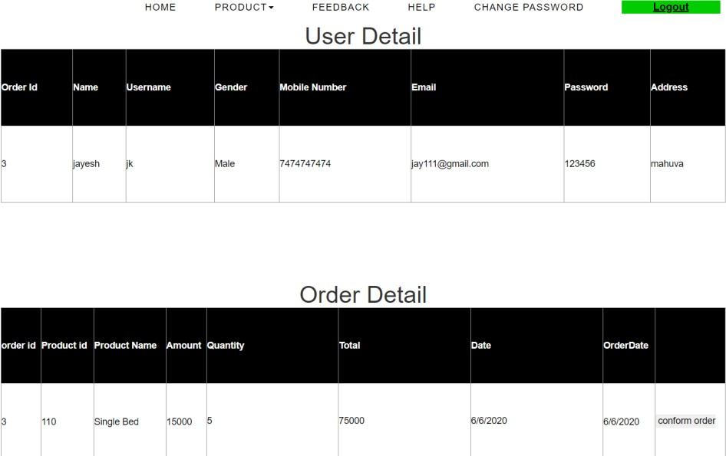[Order]**

**[Order Details]**

# Feedback:

# 

[**Feedback]**

# Change Password

# 

**  **

**[User: Change Password]**

* **User- Help:**

# 

**[User Help]**

# Logout:

# [Logout]

* **Admin authority:**

**Admin Side**

**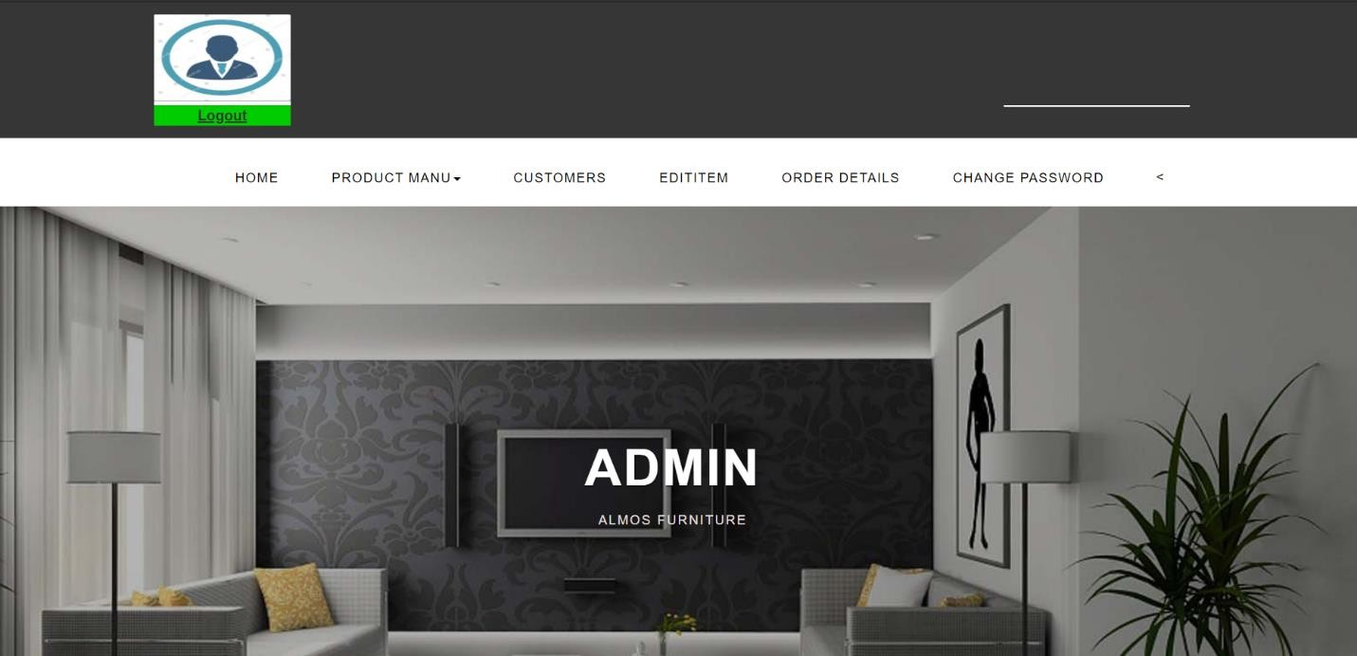**

**[Admin authority]**

# Product Menu:

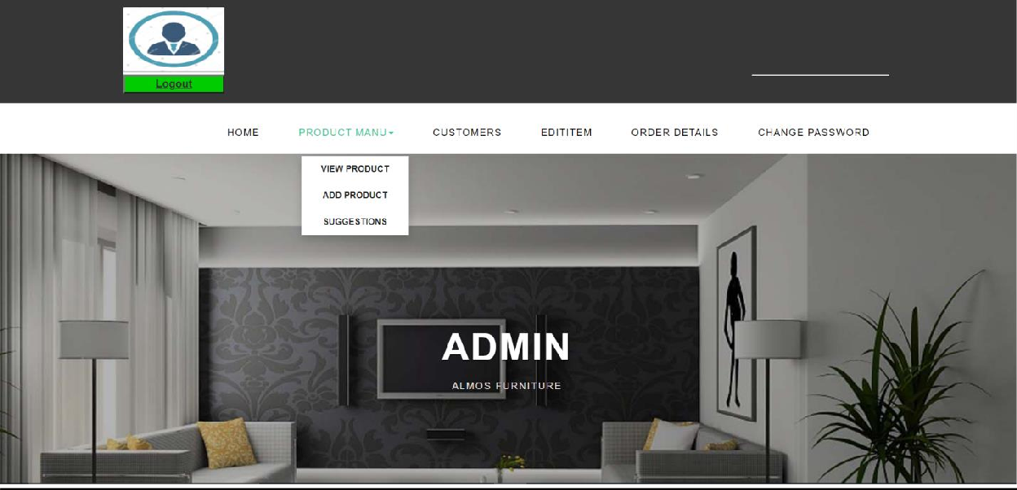

# 

* **View Product:**

# 

**[View Product]**

# Suggestions:

# screenshot-localhost_3720-2022.02.01-15_04_31.png

**[Admin: Suggestions]**

# Add Product:

# screenshot-localhost_3720-2022.02.01-15_04_31.png

**[Add Product]**

* **Customer Detail:**

**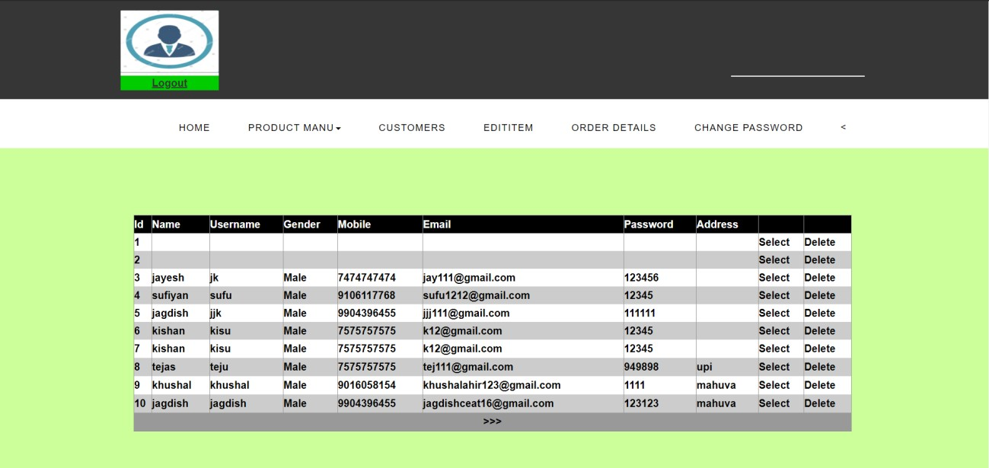**

**[Admin: Customer Data]**

# Edit Item Menu:

**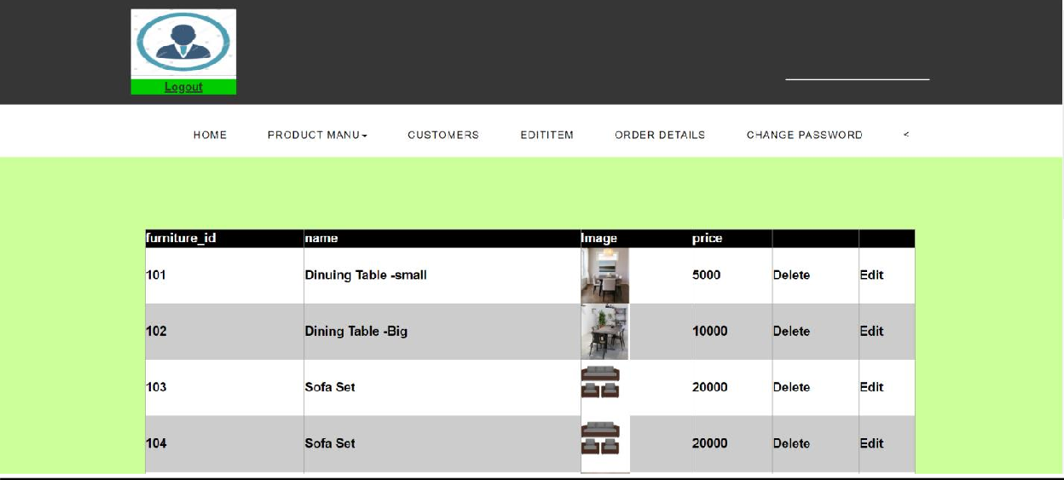**

**[Admin: Edit Item]**

* **Order Details:**

**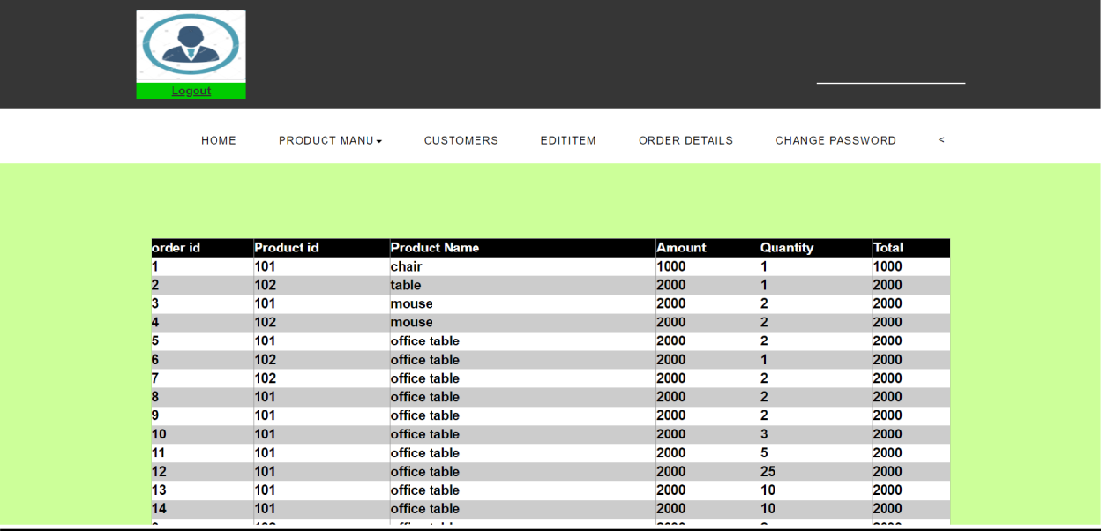[Admin: User Order Detail]**

# Change Password(Admin):

**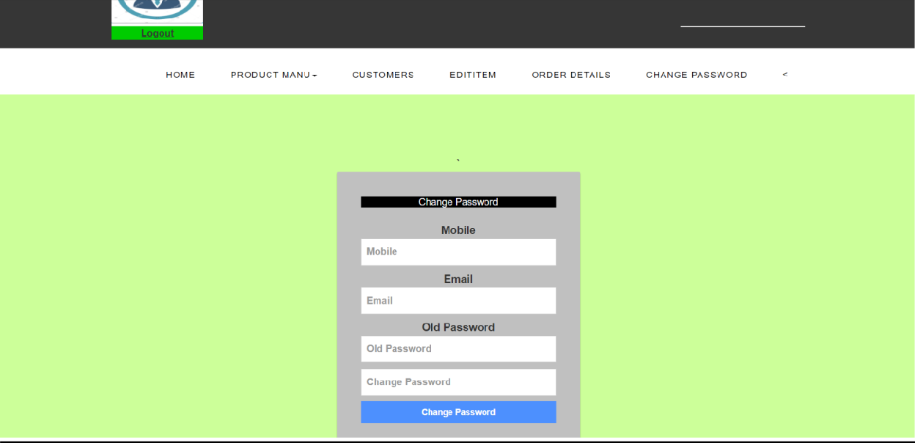[Admin: Change password]**

# Admin : Logout:

**[Admin: Logout]**

# 

**Chapter – 4 : Testing and Implentation**

**4.1 Testing approach used**

* **Definition:**
* **Black box testing:** Testing, either functional or non-functional, without reference to the internal structure of the component or system.
* Black Box, also known as Behavioral Testing, is a software testing methods in which the internal structure/design/implementation of the item being tested is not known to the tester. These tests can be functional or

non-functional, though usually functional.

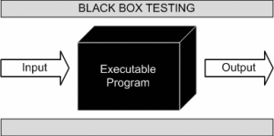

**       [Figure 61 Black Box Texting]**

* This method is named so because the software program, in the eyes of the tester, is like a black box; inside which one cannot see.
* This method attempts to find errors in the following categories:
  + Incorrect or missing functions
  + Interface errors
  + Errors in data structures or external database access
  + Behavior or performance errors
  + Initialization and termination errors.

**White Box Testing**

* White Box Testing (also known as Clear Box Testing, Open Box Testing, Glass Box Testing, Transparent Box Testing, Code-Based Testing or Structural Testing) is a software testing method in which the internal structure/design/implementation of the item being tested is known to the tester. The tester chooses inputs to exercise paths through the code and determines the appropriate outputs. Programming know-how and the implementation knowledge is essential. White box testing is testing beyond the user interface and into the nitty-gritty of a system.
* This method is named so because the software program, in the eyes of the tester, is like a white/transparent box; inside which one clearly sees.

Advantages

* Testing can be commenced at an earlier stage. One need not wait for the GUI to be available.
* Testing is more thorough, with the possibility of covering most paths. Disadvantages
* Since tests can be very complex, highly skilled resources are required, with a thorough knowledge of programming and implementation.
* Test script maintenance can be a burden if the implementation changes too frequently.
* Since this method of testing is closely tied to the application being tested, tools to cater to every kind of implementation/platform may not be readily available.
* **Grey Box Testing**
* Grey Box testing is testing technique performed with limited information about the internal functionality of the system. Grey Box testers have access to the detailed design documents along with information about requirements.
* Grey Box tests are generated based on the state-based models, UML Diagrams or architecture diagrams of the target system.

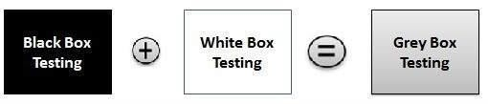

**[Figure 62 Grey Box Texting]**

* **Grey-box testing Techniques:**
* Regression testing
* Pattern Testing
* Orthogonal array testing
* Matrix testing

**Benefits:**

* Grey-box testing provides combined benefits of both white-box and black-box testing
* It is based on functional specification, UML Diagrams, Database Diagrams or architectural view
* Grey-box tester handles can design complex test scenario more intelligently
* The added advantage of grey-box testing is that it maintains the boundary between independent testers and developers.

**Drawbacks:**

* In grey-box testing, complete white box testing cannot be done due to inaccessible source code/binaries.
* It is difficult to associate defects when we perform Grey-box testing for a distributed system.

**Chapter – 4 : Testing and Implentation**

**5.1 Conclusion**

* Finally in furniture shop management system, we have a system where a user who gives orders according to the choice of type of wood, usage area, cost, small or large, color, and he can also give order for the customized item and specify the attributes and then next is ordering it and get the item.
* Admin assigns the wood, tools, and staff to the customized item to make and then complete it on time as mentioned. So it all working fine.

**5.2 Limitations**

* No online
* You must have pc/laptop
* Limited area covered
* Security

**5.3 Future Scope of System**

* Nothing is perfect in this world. So, we are also no exception. Although, we have tried our best to present the information effectively, yet, there can be further enhancement in the Application.
* We have taken care of all the critical aspects, which need to take care of during the development of the Project.
* Like the things this project also has some limitations and can further be enhances by
* Someone, because there are certain drawbacks that do not permit the system to be 100%
* Accurate.
* **Some key Feature we can add in This System Like:**
* We can provide facilities like offer letter, joining letter and Experience letter.

**5.4 Bibliography**

<https://www.w3schools.com/>

<https://www.wikipedia.org/>

<https://www.google.com/>

https://[www.stackoverflow.com/s](http://www.stackoverflow.com/s)

